# Stations of the Cross – Clarence Enzler

# Introduction

Priest: In tonight’s Stations of the Cross, there are two voices; the first is “Our Lord’s” and the second is “Our reply”.

+++++++++++++

Priest: In the name of the Father and of the Son and of the Holy Spirit. **Amen**

**Christ speaks** These fifteen steps that you are now about to walk you do not take alone. I walk with you. Though you are you, and I am I, yet we are truly one – one Christ.

And therefore my way of the cross two thousand years ago and your “way” now are also one.

But note this difference. My life was incomplete until I crowned it by my death. Your fifteen steps will only be complete when you have crowned them by your life.

## *Please move to the First Station as we sing:*

Take up thy cross, the Saviour said,

if thou wouldst my disciple be:

deny thyself, the world forsake,

and humbly follow after me.

Take up thy cross: let not its weight

fill thy weak spirit with alarm;

his strength shall bear thy spirit up,

and brace thy heart, and nerve thine arm.

# 1 Jesus is Condemned to death

Priest: We adore you, O Christ, and we bless you

**All: For by your cross, you have redeemed and saved us.**

**Christ speaks** In Pilate’s hands, my other self, I see my Father’s will. Though Pilate is unjust, he is the lawful governor and he has power over me. And so the Son of God obeys.

If I can bow to Pilate’s rule because this is my Father’s will, can you refuse obedience to those whom I place over you?

**I reply** My Jesus, Lord, obedience cost you your life. For me it costs an act of will – no more – and yet how hard it is for me to bend.

Remove the blinkers from my eyes that I may see that it is you whom I obey in all who govern me. Lord, it is you.

*As we walk to the next station, we sing:*

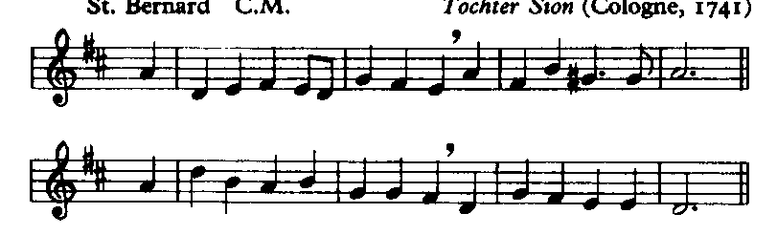

All ye who seek for sure relief

in trouble and distress,

whatever sorrow vex the mind,

or guilt the soul oppress;

# 2 Jesus Receives His Cross

Priest: We adore you, O Christ, and we bless you

**All: For by your cross, you have redeemed and saved us.**

**Christ speaks** This cross, this chunk of tree, is what my Father chose for me. The crosses you must bear are largely products of your daily life. And yet my Father chose them, too, for you. Receive them from his hands.

Take heart, my other self, I will not let your burdens grow one ounce too heavy for your strength.

**I reply** My Jesus, Lord, I take my daily cross. I welcome the monotony that often marks my day, discomforts of all kinds, the summer’s heat, the winter’s cold, my disappointments, tensions, setbacks, cares.

Remind me often that in carrying my cross, I carry yours with you. And though I bear a sliver only of your cross, You carry all of mine, except a sliver, in return.

*As we walk to the next station, we sing:*

Jesus, who gave himself for you

upon the cross to die,

opens to you his sacred heart:

O to that heart draw nigh.

# 3 Jesus Falls for the First Time

Priest: We adore you, O Christ, and we bless you

**All: For by your cross, you have redeemed and saved us.**

**Christ speaks** The God who made the universe, and holds it in existence by his will alone, becomes a man, too weak to bear a piece of timber’s weight. How human in his weakness is the Son of God. My Father willed it thus. I could not be your model otherwise.

If you would be my other self, you also must accept without complaint your human frailties.

**I reply** Lord Jesus, how can I refuse?

I willingly accept my weaknesses, my irritations and my moods, my headaches and fatigue, all my defects of body, mind and soul.

Because they are your will for me, these “handicaps” of my humanity, I gladly suffer them.

Make me content with all my discontents, but give me strength to struggle after you.

*As we walk to the next station, we sing:*

Ye hear how kindly he invites;

ye hear his words so blest:

‘All ye that labour come to me,

and I will give you rest.’

# 4 Jesus Meets His Mother

Priest: We adore you, O Christ, and we bless you

**All: For by your cross, you have redeemed and saved us.**

**Christ speaks** My mother sees me whipped. She sees me kicked and driven like a beast. She counts my every wound. But though her soul cries out in agony, no protest or complaint escapes her lips or even enters her thoughts.

She shares my martyrdom – and I share hers. We hide no pain, no sorrow, from each other’s eyes. This is my Father’s will.

**I reply** My Jesus, Lord, I know what you are telling me. To watch the pain of those we love is harder than to bear our own. To carry my cross after you, I, too, must stand and watch the sufferings of my dear ones – the heartaches, sicknesses and grief of those I love. And I must let them watch mine, too.

I do believe – for those who love you all things work together unto good.

*As we walk to the next station, we sing:*

O Jesus, joy of saints on high,

thou hope of sinners here,

attracted by those loving words

to thee we lift our prayer.

# 5 The Cross of Jesus is carried by Simon

Priest: We adore you, O Christ, and we bless you

**All: For by your cross, you have redeemed and saved us.**

**Christ speaks** My strength is gone; I can no longer bear the cross alone. And so the legionnaires make Simon give me aid. This Simon is like you, my other self.

Give me your strength. Each time you lift some burden from another’s back, you lift as with your very hand the cross’ awful weight that crushes me.

**I reply** Lord, make me realize that every time I wipe a dish, pick up an object off the floor, assist a child in some small task, or give another preference in traffic or the store; each time I feed the hungry, clothe the naked, teach the ignorant, or lend my hand in any way – it matters not to whom – my name is Simon. And the kindness I extend to them I really give to you.

*As we walk to the next station, we sing:*

Wash thou our wounds in that dear blood

which from thy heart doth flow;

a new and contrite heart on all

who cry to thee bestow.

# 6 Veronica wipes the face of Jesus

Priest: We adore you, O Christ, and we bless you

**All: For by your cross, you have redeemed and saved us.**

**Christ speaks** Can you be brave enough, my other self, to wipe my bloody face? Where is my face, you ask?

At home whenever eyes fill up with tears, at work when tensions rise, on playgrounds, in the slums, the courts, the hospitals, the jails – wherever suffering exists – my face is there. And there I look for you to wipe away my blood and tears.

**I reply** Lord, what you ask is hard. It calls for courage and self sacrifice, and I am weak. Please give me strength. Don’t let me run away because of fear.

Lord, live in me and act in me and love in me. And not in me alone – in all of us – so that we may reveal no more your bloody but your glorious face on earth.

*As we walk to the next station, we sing:*

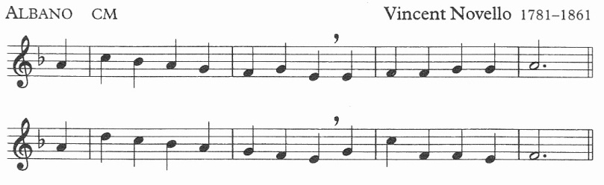

O Dearest Lord, thy sacred head

with thorns was pierced for me;

O pour thy blessing on my head

that I may think for thee.

# 7 Jesus Falls for the Second Time

Priest: We adore you, O Christ, and we bless you

**All: For by your cross, you have redeemed and saved us.**

**Christ speaks** This seventh step, my other self, is one that tests your will. From this fall learn to persevere in doing good.

The time will come when all your efforts seem to fail and you will think, “I can’t go on.”

Then turn to me my heavy-laden one, and I will give you rest. Trust me and carry on.

**I reply** Give me your courage, Lord. When failure presses heavily on me and I am desolate, stretch out your hand to lift me up.

I know I must not cease, but persevere in doing good.

But help me, Lord, Alone there’s nothing I can do. With you, I can do anything you ask. I will.

*As we walk to the next station, we sing:*

O Dearest Lord, thy sacred hands

with nails were pierced for me;

O shed thy blessing on my hands

that they may work for thee.

# 8 Jesus meets the Women of Jerusalem

Priest: We adore you, O Christ, and we bless you

**All: For by your cross, you have redeemed and saved us.**

**Christ speaks** How often had I longed to take the children of Jerusalem and gather them to me. But they refused. And now these women weep for me and my heart mourns for them – mourns for their sorrows that will come.

I comfort those who seek to solace me.

How gentle can you be, my other self? How kind?

**I reply** My Jesus, your compassion in your passion is beyond compare.

Lord, teach me, help me learn. When I would snap at those who hurt me with their ridicule, those who misunderstand, or hinder me with some misguided helpfulness, those who intrude upon my privacy – then help me curb my tongue. May gentleness become my cloak. Lord, make me kind like you.

*As we walk to the next station, we sing:*

O Dearest Lord, thy sacred feet

with nails were pierced for me;

O pour thy blessing on my feet

that they may follow thee.

# 9 Jesus falls for the Third Time

Priest: We adore you, O Christ, and we bless you

**All: For by your cross, you have redeemed and saved us.**

**Christ speaks** Completely drained of strength I lie, collapsed, upon the cobblestones. My body cannot move. No blows, no kicks, can rouse it up. And yet my will is mine. And so is yours.

Know this, my other self, your body may be broken, but no force on earth and none in hell can take away your will. Your will is yours.

**I reply** My Lord, I see you take a moment’s rest then rise and stagger on. And I can do the same because my will is mine. When all my strength is gone and guilt and self-reproach press me to earth and seem to hold me fast, protect me from the sin of Judas – save me from despair!

Lord, never let me feel that any sin of mine is greater than your love. No matter what my past has been I can begin anew.

*As we walk to the next station, we sing:*

O Dearest Lord, thy sacred heart

with spear was pierced for me;

O pour thy Spirit in my heart

that I may live for thee.

# 10 Jesus Is Stripped

Priest: We adore you, O Christ, and we bless you

**All: For by your cross, you have redeemed and saved us.**

**Christ speaks** Behold my other self, the poorest king who ever lived. Before my creatures I stand stripped. The cross – my deathbed – even this is not my own. Yet who has ever been so rich? Possessing nothing, I own all – my Father’s love.

If you, too, would own everything, be not solicitous about your food, your clothes or even your life.

**I reply** My Lord, I offer you my all – whatever I possess, and more, my self.

Detach me from the craving for prestige, position, wealth. Root out of me all trace of envy of my neighbour who has more than I. Release me from the vice of pride, my longing to exalt myself, and lead me to the lowest place. May I be poor in spirit, Lord, so that I can be rich in you.

*As we walk to the next station, we sing:*

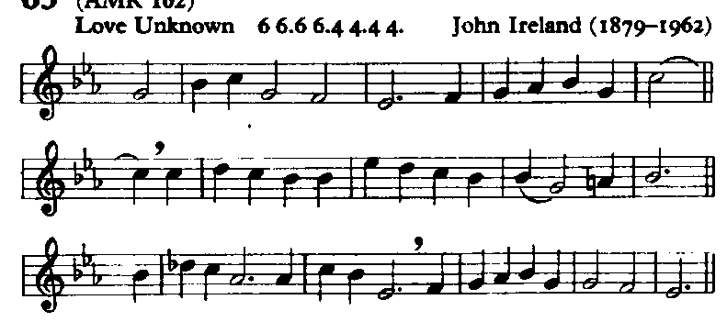

My song is love unknown,

my Saviour’s love to me,

love to the loveless shown,

that they might lovely be.

O who am I, that for my sake

my Lord should take frail flesh, and die?

# 11 Jesus is nailed to the Cross

Priest: We adore you, O Christ, and we bless you

**All: For by your cross, you have redeemed and saved us.**

**Christ speaks** Can you imagine what a crucifixion is? My executioners stretch my arms; they hold my hand and wrist against the wood and press the nail until it stabs my flesh. Then, with one heavy hammer smash, they drive it through – and pain bursts like a bomb of fire in my brain. They seize the other arm; and agony again explodes. Then raising up my knees so that my feet are flat against the wood, they hammer them fast, too.

**I reply** My God, I look at you and think: “Is my soul worth this much?” What can I give you in return? I here and now accept for all my life whatever sickness, torment, agony may come. To every cross I touch my lips.

O blessed cross that lets me be – with you – a co-redeemer of humanity.

*As we walk to the next station, we sing:*

He came from his blest throne,

salvation to bestow;

but men made strange, and none

the longed-for Christ would know.

But O, my Friend, my Friend indeed,

who at my need his life did spend!

# 12 Jesus speaks to his mother

Priest: We adore you, O Christ, and we bless you

**All: For by your cross, you have redeemed and saved us.**

**Christ speaks** They said they would stay with me, whatever happened. And now, my other self, it has happened - where are they? But you, Mary, Mother, have remained faithful. And your pain is almost as great as mine. From the pain of childbirth to the pain of death, you have never left me.

I cannot go on alone – you know that with a mother’s intuition, and that is why you are here.

**I speak** Lord, when I am tempted to think that I don’t need anyone else; remind me of your cross. When I am tempted to ignore another’s pain and sorrow, remind me of Mary’s faithfulness. When I find myself alone, or weighed down by anxiety or pain, may I come to the foot of your cross and offer myself to you?

Increase in me sensitivity, and never let me fall into the sin of ignoring the needs of others, lest I also forget your suffering for my sake.

*As we walk to the next station, we sing:*

Sometimes they strew his way,

and his sweet praises sing;

resounding all the day

hosannas to their King.

Then ‘Crucify!’ is all their breath,

and for his death they thirst and cry.

# 13 Jesus Dies on the Cross

Priest: We adore you, O Christ, and we bless you

**All: For by your cross, you have redeemed and saved us.**

**Christ speaks** The cross becomes a pulpit now – “Forgive them, Father….You will be with me in Paradise….There is your mother….There…your son….I thirst….It is complete.”

To speak I have to raise myself by pressing on my wrists and feet, and every move engulfs me in new waves of agony. And then, when I have borne enough, have emptied my humanity, I let my mortal life depart.

**I reply** My Jesus, God, what can I say or do?

I offer you my death with all its pains, accepting now the time and kind of death in store for me. Not by a single instant would I lengthen my life’s span. I offer you my death for my own sins and for those of all humanity. My God! My God! Forsake us not. We know not what we do.

*As we walk to the next station, we sing:*

Why what hath my Lord done?

What makes this rage and spite?

He made the lame to run,

he gave the blind their sight.

Sweet injuries! yet they at these

themselves displease, and ‘gainst him rise.

# 14 Jesus Is Taken Down from the Cross

Priest: We adore you, O Christ, and we bless you

**All: For by your cross, you have redeemed and saved us.**

**Christ speaks** The sacrifice is done. Yes, my Offering is complete; but not my mother’s – and not yours, my other self. My mother still must cradle in her arms the lifeless body of the son she bore. You, too, must part from those you love, and grief will come to you.

In your bereavements think of this: A multitude of souls were saved by Mary’s sharing in my Calvary. Your grief can also be the price of souls.

**I reply** I beg you, Lord, help me accept the partings that must come – from friends who go away, my children leaving home, and most of all, my dear ones when you shall call them to yourself.

Then, give me grace to say: “As it has pleased you, Lord, to take them home, I bow to your most holy will. And if by just one word I might restore their lives against your will, I would not speak.”

Grant them eternal joy.

*As we walk to the next station, we sing:*

They rise, and needs will have

my dear Lord made away;

a murderer they save,

the Prince of Life they slay.

Yet cheerful he to suffering goes,

that he his foes from thence might free.

# 15 Jesus Is Laid in the tomb

Priest: We adore you, O Christ, and we bless you

**All: For by your cross, you have redeemed and saved us.**

**Christ speaks** So ends my mortal life.

But now another life begins for Mary, and for Magdalen, for Peter and for John and you. My life’s work is done. My work within and through my church must now commence. I look to you, my other self. Day in, day out, from this time forth, be my apostle – victim – saint.

**I reply** My Jesus, Lord, You know my spirit is as willing as my flesh is weak.

The teaching you could not impart, the sufferings you could not bear, the works of love you could not do in your short life on earth, let me impart, and bear, and do through you. But I am nothing, Lord. Help me!

*As we return to our pews in the Lady Chapel, we sing:*

In life, no house, no home

my Lord on earth might have;

in death, no friendly tomb

but what a stranger gave.

What may I say? Heaven was his home;

but mine the tomb wherein he lay.

Here might I stay and sing:  
no story so divine;

never was love, dear King,

never was grief like thine!

This is my Friend, in whose sweet praise

I all my days could gladly spend.

# Conclusion

**Christ speaks** I told you at the start, my other self, my life was not complete until I crowned it by my death. Your “way” is not complete unless you crown it by your life.

Accept each moment as it comes to you, with faith and trust that all that happens has my mark on it. A simple fiat, this is all it takes; a breathing in your heart, “I will it, Lord.”

So seek me not in far-off places. I am close at hand. Your workbench, office, kitchen, these are altars where you offer love. And I am with you there.

Go now! Take up your cross and with your life complete your way.

*We remain kneeling for the final hymn*

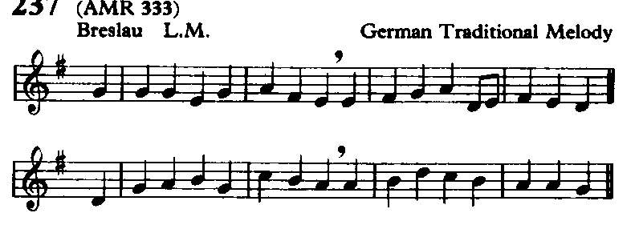

Take up thy cross, the Saviour said,

if thou wouldst my disciple be:

deny thyself, the world forsake,

and humbly follow after me.

Take up thy cross, and follow Christ,

nor think till death to lay it down;

for only they who bear the cross

may hope to wear the glorious crown.

Priest: Most merciful God, who by the death and resurrection of your Son Jesus Christ delivered and saved the world: grant that by faith in him who suffered on the cross, we may triumph in the power of his victory; through Jesus Christ our Lord. **Amen**

Christ give you grace to grow in holiness, to deny yourselves, take up your cross, and follow him; and the blessing of God almighty, the Father, the Son and the Holy Spirit be among you and remain with you always. **Amen**

-------------------